PART A

(PART A: TO BE REFERRED BY STUDENTS)

Experiment No.01

A.1—Aim:
The objective of this lab is to guide students through the process of installing Kali Linux, a widely used penetration testing and ethical hacking distribution, in a Virtual Box virtual machine. This setup will provide a controlled and isolated environment for students to practice ethical hacking techniques. Along with Installation this experiment covers a case study of common ethical hacking tools for every step ethical hacking.

A.2--- Prerequisite:
Oracle Virtual Box installed on the host machine. Download from VirtualBox.
Kali Linux ISO file. Download from Kali Linux.

A.3--- Outcome:
After successful completion of this experiment students will be able to:
- Virtual Machine Proficiency: Students will develop proficiency in setting up and managing virtual machines using Virtual Box, including resource allocation and system configuration.
- Kali Linux Installation Skills: Students will gain practical experience in installing and configuring Kali Linux, providing a foundation for further exploration and practice in ethical hacking techniques.
A.4--- Tasks:
1. Downloading the Installation Image of Kali Linux
Go to the official website and download the ISO image of Kali Linux. There are multiple 32-bit and 64-bit images. Each image allows you to select one of the graphical user interfaces (Gnome, KDE, XFCE, LXDE, etc.) during installation. The latest version is available on the main download page. You can also download older Kali Linux images if needed.

Let’s download Kali Linux 64-bit v.2023.3 and then go over the installation process. You can download images via HTTP and Torrent protocols. Save the ISO file to a custom folder, for example, D:\VirtualBox\kali-linux-2023.3-installer-amd64.iso. You can also verify the SHA256 checksum to make sure that your image is consistent after finishing downloading.
2.

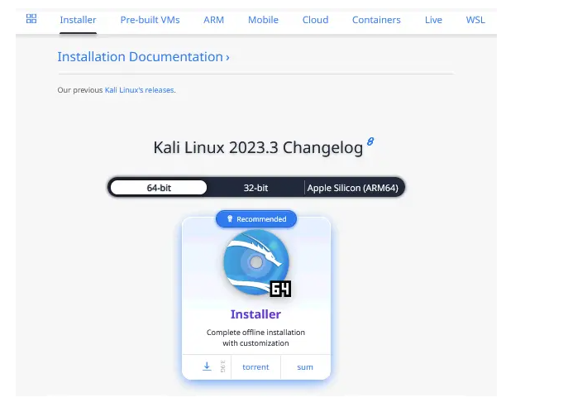

2. Creating a new VM
Once you have downloaded the installation image, you can create a new VM.

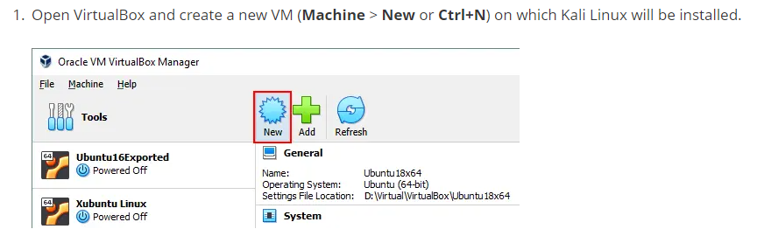

2. Set the following VM parameters in the appropriate sections:
Name and Operating System
Name: Kali_x64
Machine Folder: D:\Virtual\VirtualBox (Try not to use a system partition C: to store VMs).
Type: Linux
Version: Debian (64-bit)
Hardware
Memory size: 4096 MB.
The VM memory size must be large enough to run a guest OS, though you should leave enough unallocated memory to run your host OS. In our example, a host machine with 16 GB of RAM is used, which leaves enough memory for a host OS.
Processors: 1 CPU
Hard Disk
Create a virtual hard disk now.
Set the virtual disk file location, for example, D:\Virtual\VirtualBox\Kali_x6Kali_x64.vdi
It is recommended that you store virtual disk files in the VM folder (this folder is selected by default).

Set the virtual disk file size – at least 20 GB.
Hard disk file type: VDI. A native VirtualBox format is selected.
Storage on physical disk: Dynamically allocated (the analog of thin provisioning in VMware). Click Create to finish creating the new VM.

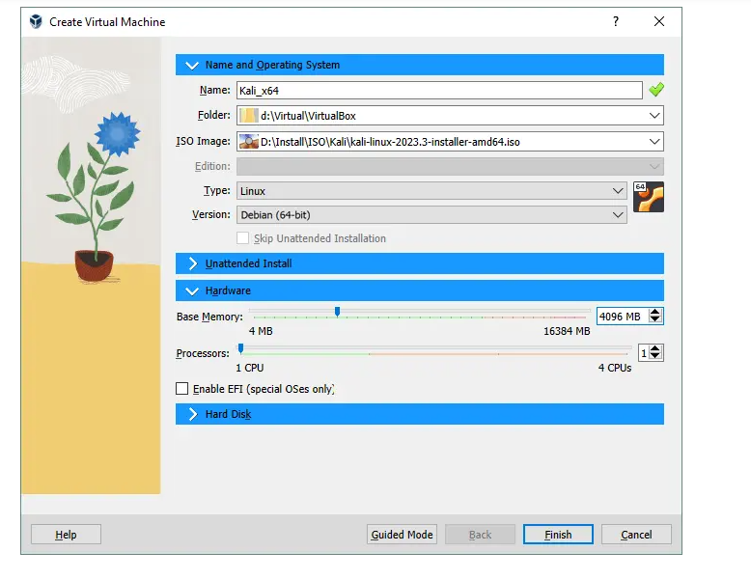
3. After creating a new VM, you should configure some additional settings. Select your recently created virtual machine and open the VM settings by clicking the appropriate icon.
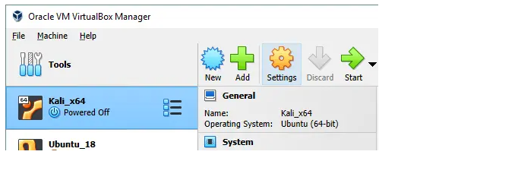

Display options
Go to Display > Screen and set Video Memory to 128 MB. This will prevent the installer from hanging.
Next, select the checkbox Enable 3D acceleration (optional). It will be useful for applications that need 3D acceleration and help to avoid performance degradation.
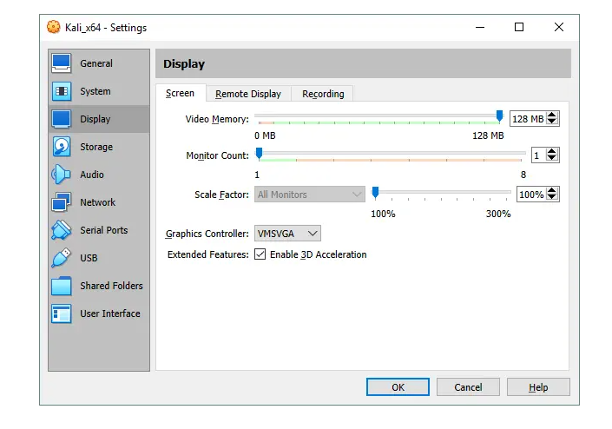
Network options
Go to the network settings and select the networking mode of the VM’s virtual network adapter.
Let’s select the Bridged mode to use the VM network adapter as you would for a physical network adapter of a host machine. In this case, the VM network adapter is connected to the same physical network as the host machine.
You can set additional options such as network adapter name, type, MAC address, etc
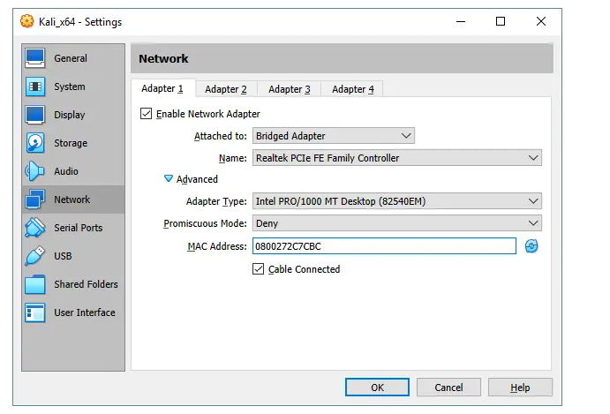
Installing Kali Linux on VirtualBox: Step-by-step Guide
Now, you can start your new VM (Kali_x64 in this case) and begin the Kali installation.
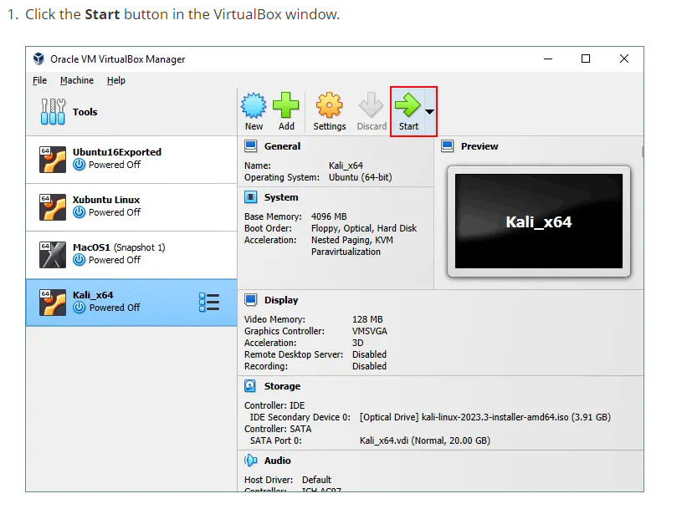
2. After booting from a virtual DVD, you will see a boot menu where you can select boot options for Kali Linux, such as Boot from Live DVD, Install, Graphical Install, etc. Select Graphical Install. Press Enter to continue.
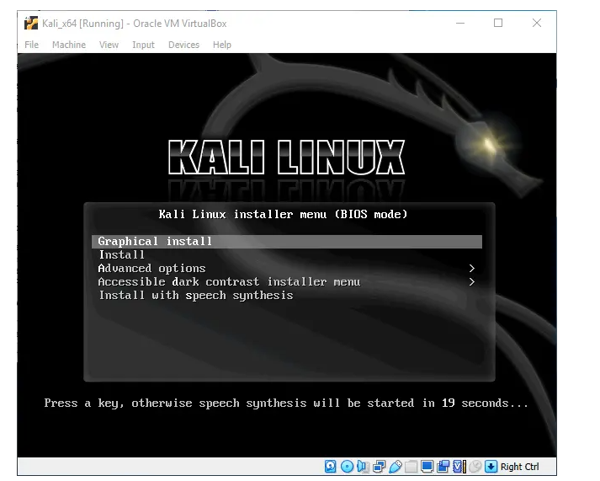
3. Select a language. Choose the language you wish to use for the installation process and the installed system. English is selected for our installation. Click the Continue button on each screen to move forward.
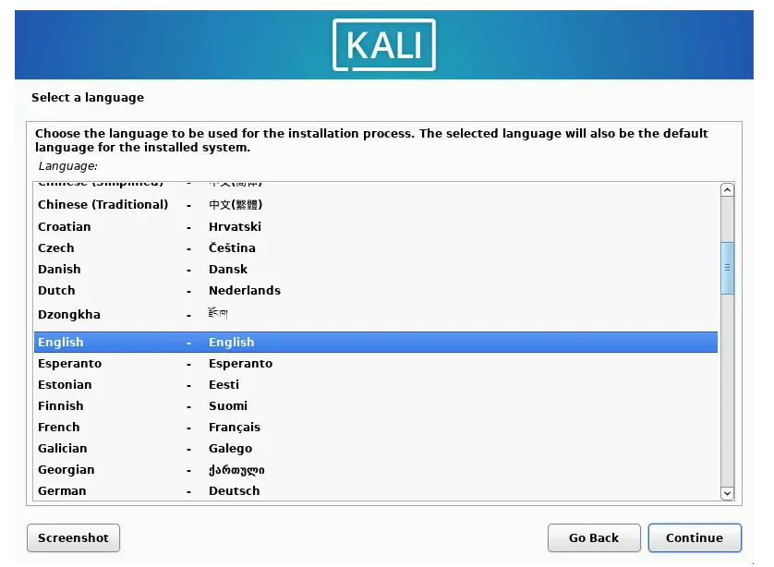
4. Select your location. This option is used to set your time zone, time format, etc. United States is selected in our example.
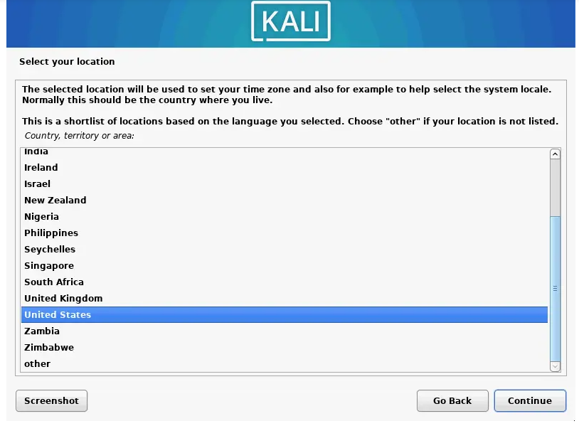
5. Configure the keyboard. Select your keyboard layout. We use American English.
6. 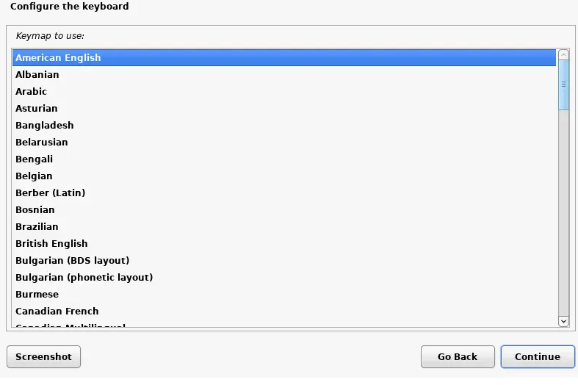
6. Configure the network. Enter the hostname for your Linux system, for example, kali-virtualbox.
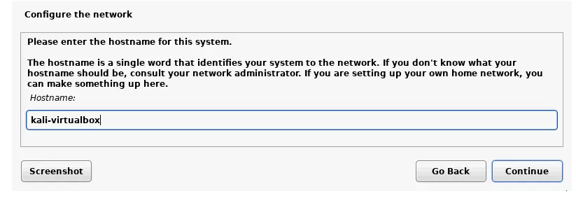
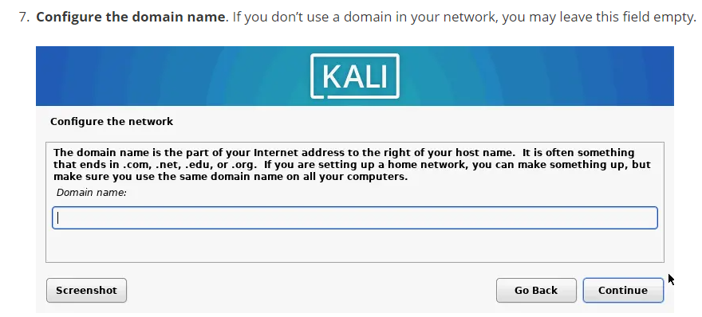
7. Configure the domain name. If you don’t use a domain in your network, you may leave this field empty
8. Set up users and passwords. Enter the full name of your user that can be the same as the username or not. This user account will be used to log in to Kali Linux on VirtualBox. We create user1 for this purpose.
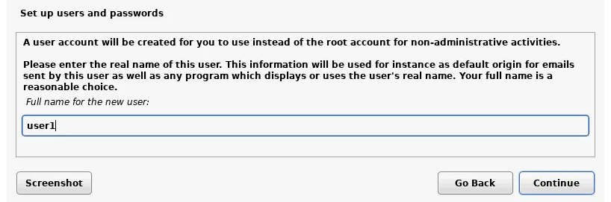

9. Enter a username for your account. While the previous screen requested a full user name for the explanation of the user, this screen requests that you enter a username for the account registered in the Linux system. We create an account named user1.
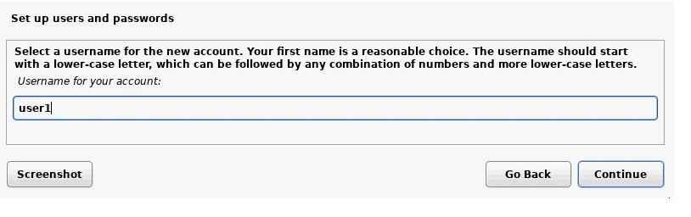

10. User password. Enter the password for the created user and confirm this password
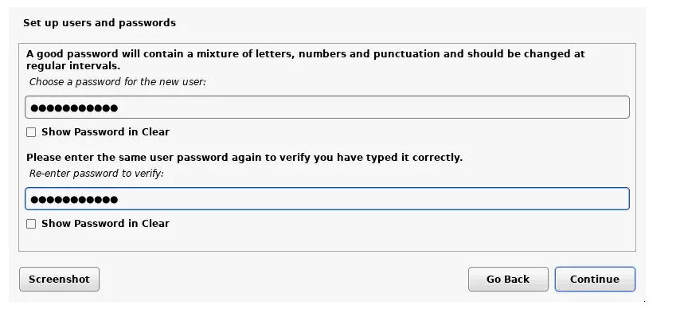
11. Configure the clock. Now, you can select a precise time zone for your country
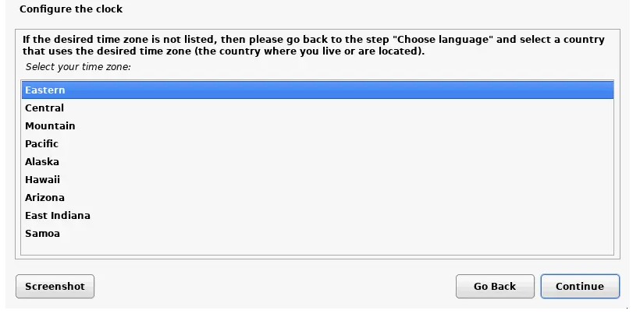
12. Partition disks. You can use manual and guided partitioning of disks. For the first time, you can select Guided – use entire disk. The entire disk will be used for creating one big partition.
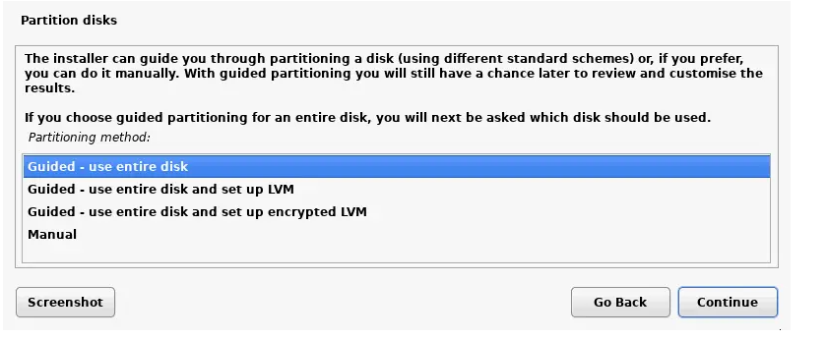
13. Confirm that you want to erase the disk. There’s no reason for concern in this case, as the empty 20-GB virtual disk is used for partitioning. Note that VirtualBox uses binary (real) Gigabytes while the Kali Linux installer uses decimal Gigabytes (where 1 GB = 1000 MB) – that’s why the number differs.

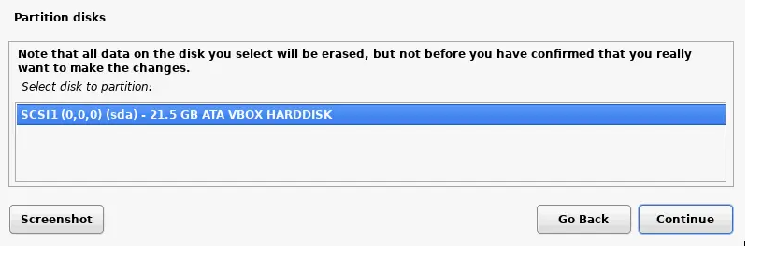

13. Select a preferred partitioning scheme for your virtual disk. Let’s select All files in one partition.
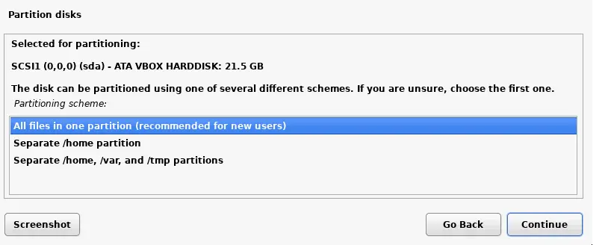

14. Check the overview and select Finish partitioning and write changes to disk.
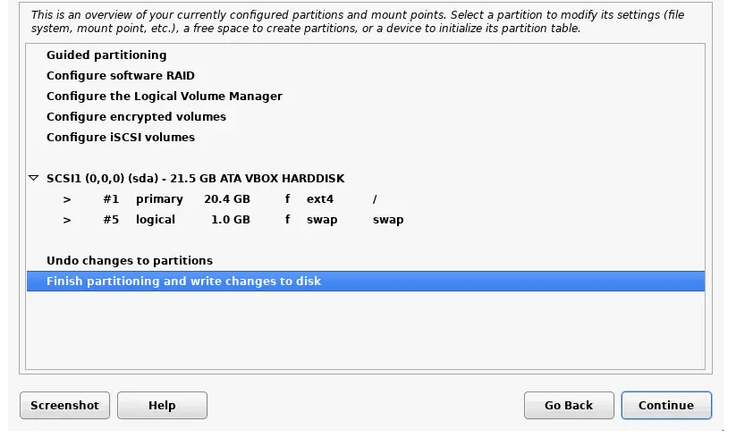
16. Select Yes and confirm that you would like to write changes to the disk
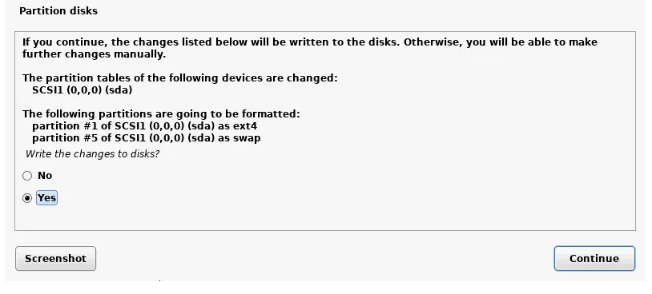
17. Wait for the system to be installed. As Kali Linux is being installed, the files are being copied to the virtual disk of the VM.
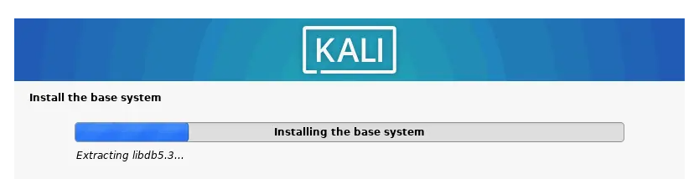
18. Software selection. Select the desktop environment for the graphical user interface of Kali Linux. You can use Xfce by default, which is a lightweight choice.
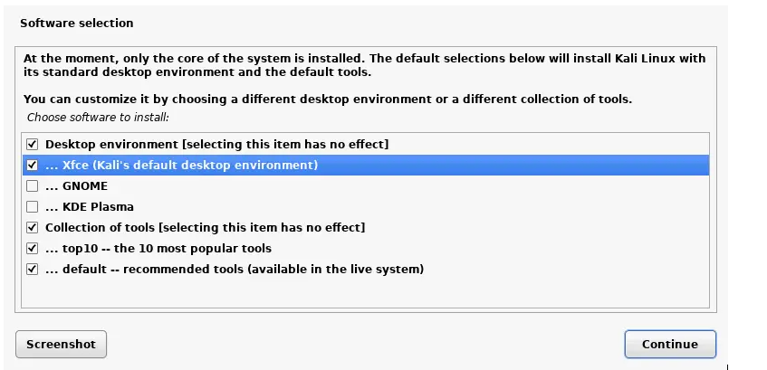
19. Install the GRUB boot loader on a hard disk. Since there are no other operating systems and boot loaders on the virtual disk, it is necessary to install GRUB in this case. Select Yes to install GRUB.
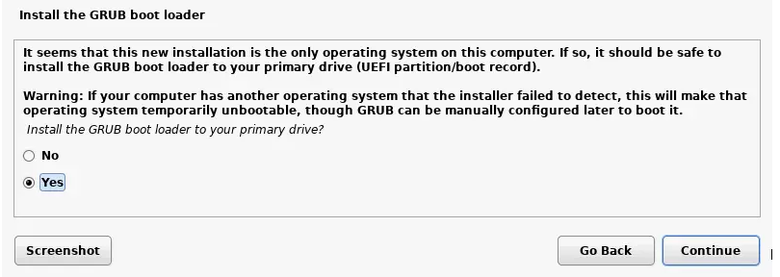

20. Select a disk on which to install GRUB. In our case, /dev/sda is the necessary disk and is the only disk connected to a VM.

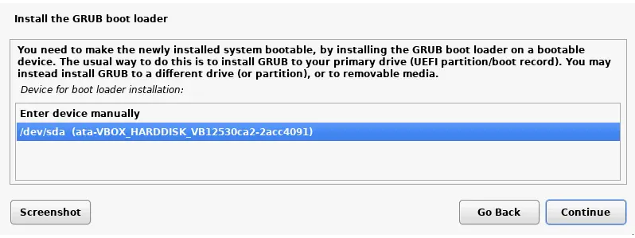

21. Finish the installation. When the installation of Kali Linux on VirtualBox is complete, you will see a notification message. Now, you can reboot the virtual machine to boot the Kali Linux installed on the VirtualBox VM.
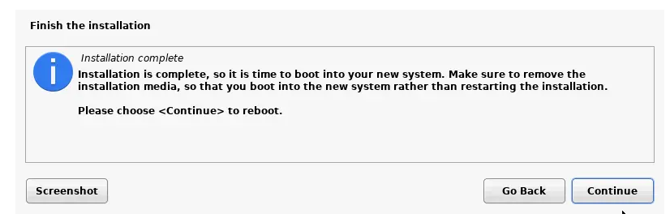

22. After the reboot, you will see the login screen of Kali Linux. Enter your username (user1 in our case) and then enter the password set while installing Kali Linux on VirtualBox to sign in.
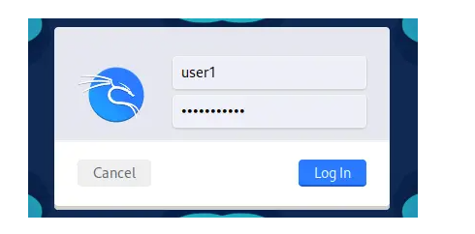

Refer: https://www.nakivo.com/blog/how-to-install-kali-linux-on-virtualbox/

Task2: Famaliarise with the Recoinnsance tools , Scanning, and Exploit tools. List any 3 in each category. Give short description of each tool and its features
- Save the file and name it as EH_EXP1_your Roll no_Batch No.
Important Links
- To download and install Virtual machine:
https://www.vmware.com/products/workstation-player.html

- To download and install kali linux on virtual machine
https://zsecurity.org/download-custom-kali/

- 7-zip
https://www.7-zip.org/

- Linux commands
https://www.mediacollege.com/linux/command/linux-command.html

- How To Use a USB Wireless Adapter With Kali In Virtual Box
https://www.youtube.com/watch?v=RiTICcLH4kU

- Shell explanation: explain linux commands
https://explainshell.com/

(PART - B)

(TO BE COMPLETED BY STUDENTS)

(Students must submit the soft copy as per the following segments within two hours of the practical. The soft copy must be submitted on the portal or on MS Teams before the deadline)

Roll.No. : | Name:
Sem/Year : | Batch:
Date of Experiment : | Date of Submission:
Grade --

B.1: Procedure of performed experiment
Students can include the output/observations as per each of tasks given in Part A

B.2: Observations and Learning’s:
(Students are expected to comment on the output obtained with clear observations and learning for each task/ sub part assigned)

B.3: Conclusion:
(Students must write the conclusion as per the attainment of individual outcome listed above and learning/observation noted in section B.2)

